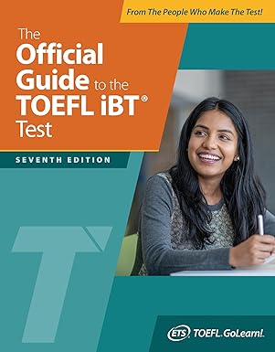 **₦**75,500

**The Official Guide to the TOEFL iBT Test, Seventh Edition (Official Guide to the TOEFL Test)**